# **CALL FOR CATALYSTS PROPOSALS**

BEFORE SUBMITTING PROPOSAL: Please check that you have included the required information

|  |  |
| --- | --- |
| 1 Committed Champion | Y |
| 4 Committed Participants | Y |
| 1 Marketing Lead | N |
| 1 Project Lead | N |

Please choose all the events that you plan to attend with your team. You may make changes to your selected events up to the submission deadline for the event you want to add or remove.

|  |  |  |
| --- | --- | --- |
| **Conference** | **Application Due Date** | **Attending? (Y/N/To be determined)** |
| TM Forum Live! Nice 2018 | December 15, 2017 | Y |

**Additional Dates:**

* Catalyst working sessions and presentations at [Action Week, Lisbon,](https://actionweek.tmforum.org/) February 2018

**What types of projects will be considered?**

In this Call for Catalysts, we ask member companies to propose Catalysts to support:

* **Open APIs**
* **Agile Business & IT**
* **OSS/BSS**
* **Customer Experience**
* **Data Analytics**
* **Internet of Everything**
* **NFV & SDN**
* **Smart Cities**
* **Security & Privacy**

|  |
| --- |
| **Submit To:**  [tfernandes@tmforum.org](mailto:tfernandes@tmforum.org)  Tania Fernandes  Catalyst Program Project Manager |

**CATALYST PROPOSAL SUBMISSION**

|  |
| --- |
| Project Name: Blockchain Unleashed |
| Submitted By: Name: Vincent Seet  Organization: Globe Telecom Inc.  Email: vseet@globe.com.ph |

**CONFIRMED CHAMPIONS AND PARTICIPANTS**

***Please enter member companies where you have obtained their explicit agreement that they will participate and please identify the contact information of the individual to whom a Catalyst agreement for this organization should be sent. You may also include Tentative participants in your submission, but a project will not be fully approved without meeting the required number of confirmed participants. For additional information, please visit our*** [***FAQ page***](https://www.tmforum.org/collaboration/catalyst-program/frequently-asked-questions/)***.***

**NOTE: A minimum of one Champion organization and four Participant companies are required per Catalyst project, though more are strongly encouraged. Roles marked in red are required; please add additional rows as needed.**

|  |  |  |  |  |
| --- | --- | --- | --- | --- |
| Role | Name | Organization | Email | Confirmed/Tentative |
| Project Leader / Co-Leader | TBA |  |  |  |
| Project Co-Leader | TBA |  |  |  |
| Marketing Lead | TBA |  |  |  |
| Champion 1 | Vincent Seet | Globe Telecom Inc | [vseet@globe.com.ph](mailto:vseet@globe.com.ph) | Confirmed |
| Champion 2 | Tomohiro Otani | KDDI | otani@kddi-research.jp | Confirmed |
| Participant 1 | Russell Sassoon | Deloitte | rsassoon@deloitte.co.uk | Confirmed |
| Participant 2 | Emmanuel Amamoo Otchere | Huawei | emmanuel.otchere@huawei.com | Confirmed |
| Participant 3 | colmm@openet.com | Openet | colmm@openet.com | Confirmed |
| Participant 4 | Gnanapriya | Infosys | gnanapriya@infosys.com | Confirmed |
| Participant 5 | Abhijeet Mohapatra | Stanford University | abhijeet@stanford.edu | Tentative |
| Participant 6 | Meng Weng Wong | Legalese.com | mengwong@legalese.com | Tentative |

**Project Overview**

|  |
| --- |
| ***Vision:*** *One Sentence Vision Statement for this Catalyst Project*  Unlocking blockchain potentials beyond FinTech industry |

|  |
| --- |
| **What is the specific business problem you are trying to address**? *This should be phrased as a user story or multiple user stories.*  ***Note that the user story below is just one of several that will likely be implemented in the catalyst. Not all participants will necessarily participate in all user stories.***  *As a provider of digital services to enterprises*  *I need to ensure that my service level agreements are created, managed and executed in a way that minimizes friction and risk*  *so that I can rely on timely settlement and absence of litigation.*  *To do this I need to ensure that my service level agreements are complete, consistent and correct, and that their execution and settlement can be automated.*  *I know that I am successful when my service level agreements are automatically executed as smart contracts.*  For this particular catalyst on blockchain, the user stories would reflect the use cases that would be explored. At this moment, the use cases are not finalized yet but there are some interesting ones to be explored such as fraud management & identity management.  The idea of this catalyst is really about exploring relevant usages of blockchain technology to disrupt solutions which CSPs have been traditionally using to support their business operations. |

|  |
| --- |
| **Use of best practices and standards:** *Please provide the necessary information outlined below for the one project category that is most appropriate to your proposal. Read both categories first to see where you fit.*   1. **Mature projects (beyond phase 1) and Deployment/Integration-Oriented Catalysts must:**  * leverage TM Forum assets to prove them out in the context of your project, * demonstrate extensions to TM Forum assets that you have created as part of the project, or * propose and prove the need for new best practices and standards (Frameworx models, APIs, best practices, etc.)    Describe the assets that you anticipate using, contributing to or creating in this project. |
| 1. **New or Exploratory Catalysts:** For new projects that have not begun to define solutions yet or projects that will explore brand new topics, pleaseexplain how you see using and/or creating standards and best practices as an important part of your project.   This catalyst will go beyond the hype of blockchain which has flooded the media to concretely demonstrate what could truly be disruptive for CSPs outside of the FinTech industry. |

**What makes this a significant problem to be solved?**

CSPs could have been adopting certain operating models and solutions to address their day-to-day business operations. The premise of blockchain seeks to eliminate the use of middle-man entities in these setups thereby disrupting the old way of thinking/solutioning for the usual classic problems which thus in turn reduces TCO and perhaps even increases revenue as a result.

One of the use cases to be demonstrated is in the area of service level agreement execution as a smart contract. This will build on from the TM Forum’s blockchain demonstration in Nice 2017, as described in the user story above and the diagram below.

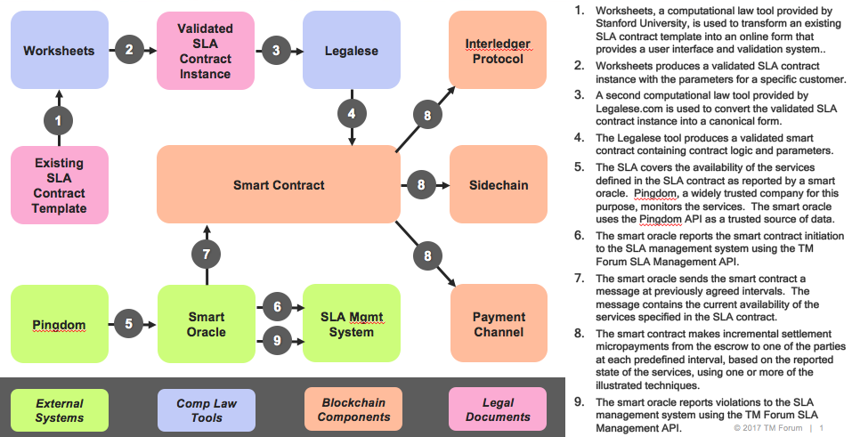

Other potential use cases that could be explored are:

- Real-time international roaming record exchange eliminating the need of clearing house

- Identity management

- Fraud management

- Grey route SMS

- Online charging & policy control using blockchain

Use cases will be finalized upon catalyst approval and team meetings during action week.

**What will change about the way your champions do business if this problem is solved?**

Business processes could be largely simplified too as well as promoting efficient use of resources.

|  |
| --- |
| **Relationships:**Does this Catalyst build on a previous Catalyst or project? If so, please identify the difference between this and the earlier phase and the reason to continue (new challenge you will be exploring or new proof point you will be tackling). NA. Does this project leverage internal TM Forum projects? If so please list and explain.  * If no participant is available for a particular role, the role may be filled by the TM Forum API Sandbox. For example, the sandbox could provide the SLA Management API for the scenario described above. * Frameworx assets would be leveraged such as relevant eTOM processes.  Does this project leverage other standards bodies or industry groups? If so please list and explain the relationship. Likely to use an open source blockchain project such as Ethereum to implement the use cases. |

|  |
| --- |
| *Other Relevant Information that will assist in the reviewing of your project:* |

BEFORE SUBMITTING PROPOSAL: Have you included the required information?

|  |  |
| --- | --- |
| 1 Committed Champion/Service Provider | Y |
| 4 Committed Participants/Vendors | Y |
| 1 Marketing Lead | N |
| 1 Project Lead | N |

# **------------------------------------------------------------------**

# **Program Information**

**Catalyst Program Fees**

* Each Catalyst project will receive exhibition space as part of the TM Forum zones in which to present their demonstration at selected events.
* There is a 25% discount for companies participating in more than one Catalyst.
* Projects will also be professionally filmed at TM Forum Action Week, Vancouver, TM Forum Action Week, Lisbon and select events
* Pricing is for Participants (actual rates may vary based on membership type)
* Champions do not pay a Catalyst fee, but are expected to contribute time and effort towards defining the challenge, establishing the business requirements/use cases, and giving feedback on solutions as they are developed.

|  |  |
| --- | --- |
|  | **TM Forum Live! 2018 (Euro-€)** |
| **Corporate A1** | **€**13,600 |
| **Corporate A2** | **€**13,600 |
| **Corporate A3** | **€**8,900 |
| **Corporate B1** | **€**8,900 |
| **Corporate B2** | **€**8,900 |
| **Corporate C** | **€**6,900 |
| **Corporate D** | **€**4,000 |
| **Corporate E** | **€**1,000 |

***Please Note****: USD prices are the same for each event (not including TM Forum Live! Nice). Euro prices are only for TM Forum Live! Nice 2018*

**Selection Guidelines**

We will accept as many projects as possible that fit the necessary requirements. Space in the Catalyst program is limited, so it is important that your proposal is presented in a clear and concise manner, focusing on business value and benefits in addition to explaining the proposed technology and the application of TM Forum best practices and standards. The proposal should follow the format on the submission form and must contain the information requested as well as meet the required specifics outlined above.

**Submissions are rated and reviewed by** the Catalyst Selection Committee, comprised of TM Forum management and technical staff, **which makes recommendations to the Collaboration Subcommittee of the TM Forum board on those projects that should be accepted for inclusion at the event. We anticipate notifying those projects that have been accepted within two weeks of submission.**

|  |  |  |
| --- | --- | --- |
| **If participating in:** | **Make sure to attend TM Forum Action Week in:** | **To be able to:** |
| TM Forum Live! Nice 2018 | Action Week, Lisbon 2018 | Meet face-to-face with your team to accelerate your project, do last minute matchmaking, and get advice from SMEs |

To be considered for inclusion in the selected 2017-2018 TM Forum events, this document must be returned to Tania Fernandes, Catalyst Program Project Manager at [tfernandes@tmforum.org](mailto:tfernandes@tmforum.org) **no later than dates listed above.** If you have any questions or would like an initial review of your Catalyst idea before submitting, please feel free to contact Jean-Pierre directly.

Skype: live:tfernandes_tmforum

Email: [tfernandes@tmforum.org](mailto:tfernandes@tmforum.org)